Kevin Rodas

Data Base Systems Coursework Part A

ID: w2151939

Tutorial Group: Tuesday 11 A.M. – 1 P.M.

Question 1
- Evaluation of the AI-Generated EERD

# | Type | Weakness: What AI-generated EERD shows | Evidence: the modelling convention (weaknesses 1-2) or a reference to a specific component of the Westlivingster brief (weaknesses 3-5) | Potential improvement: how the component could be better modelled
1 | Conceptual  Modelling conventions | The conceptual diagram includes foreign keys (FK) in entities like Tenant, Owner, Electric vehicle and Fuel Vehicle. | Conceptual models are focused on business concepts and should not include logical implementation details. | All Foreign Keys (FK) must be removed from the entities.
2 | Conceptual modelling conventions | The conceptual diagram uses diamond shapes to represent verbs. | The UML notation requirements for conceptual modelling specify the use of lines with reading direction arrows. | Replace all diamond shapes with the correct UML notation for relationships representations (straight lines containing a verb and an arrow indicating the reading direction)
3 | Semantics | The Owner entity has no relationship connecting it to the Apartment entity, and a constrain to the resident entity. | The brief clarifies that residents can buy an apartment or rent it. | Add a relation ship that connects the entities Owner and Apartment that states that an apartment can have an owner or a tenant.
4 | Semantics | The entities Vehicle and Visitor does not have a relationship, not including the possibility that visitors can also have a car. | When the brief describes the parking structure, it mentions that both residents and visitors can have a vehicle. | Add a relation ship between Vehicle and Visitor that states the possibility for the visitors to also have a car.
5 | Semantics | The multiplicities implemented along the diagram shows an “M” and a single digit number. | The brief states that there is only one tenant assigned as the lead tenant and is the only one responsible for the agreement. | Change the format for the multiplicities for an appropriate format that include participation and cardinality on both sides of the entities.

Question 2.1
- Conceptual EERD
- Simplified data dictionary (assessed under Clarity, notation and documentation).
- Table 1 Entities and specialisations
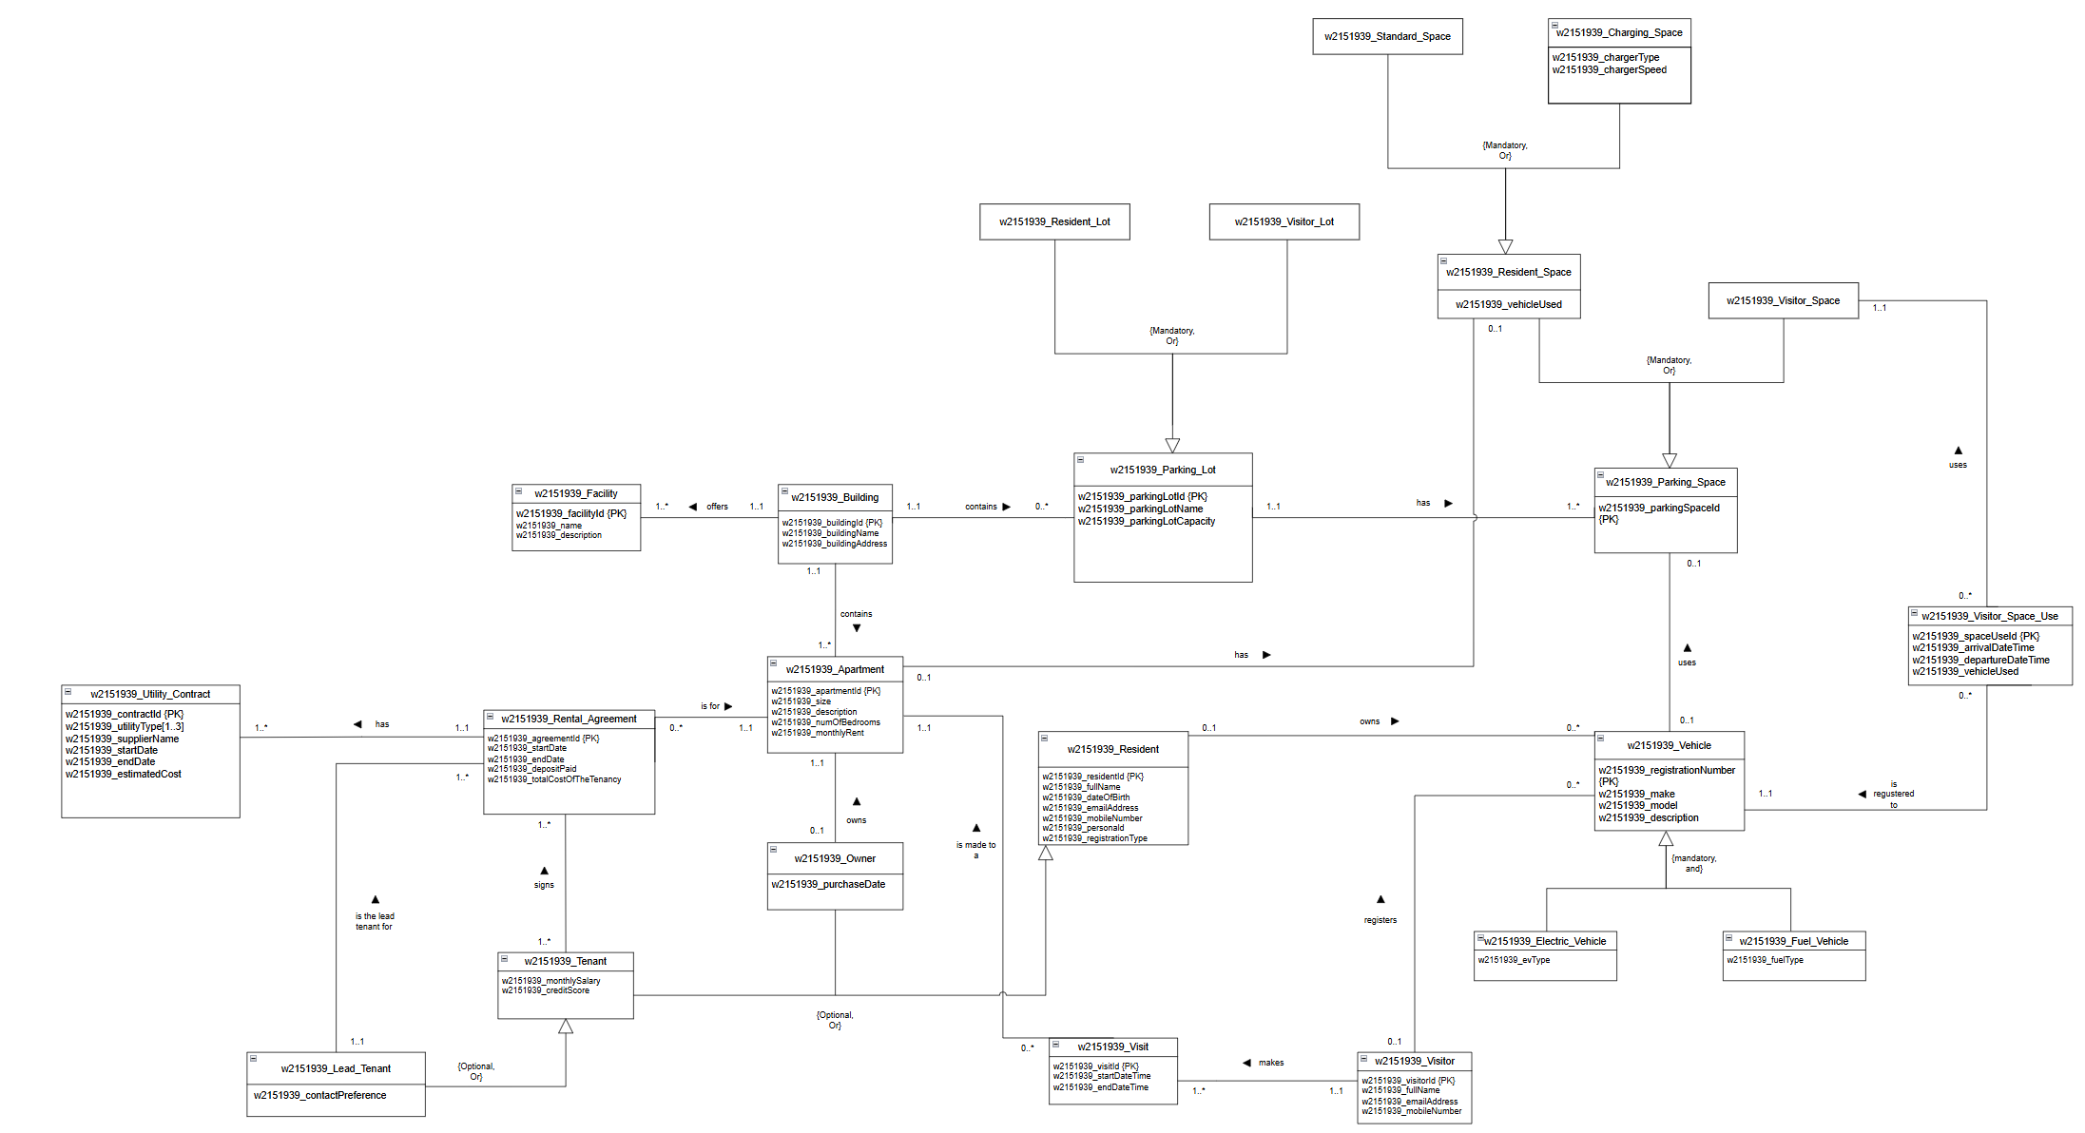
- Table 2 Relationships and multiplicities

Entity | Specialised sub-types and constraint (if any)
w2151939_Building
w2151939_Facility
w2151939_Apartment
w2151939_Parking_Lot | w2151939_Resident_Lot, w2151939_Visitor_Lot {Mandatory, Or}
w2151939_Resident_Lot
w2151939_Visitor_Lot
w2151939_Parking_Space | w2151939_Resident_Space, w2151939_Visitor_Space {Mandatory, Or}
w2151939_Resident_Space | w2151939_Standard_Space, w2151939_Charging_Space {Mandatory, Or}
w2151939_Standard_Space
w2151939_Charging_Space
w2151939_Visitor_Space
w2151939_Resident | w2151939_Tenant, w2151939_Owner {Optional, Or}
w2151939_Owner
w2151939_Tenant | w2151939_Lead_Tenant {Optional}
w2151939_Lead_Tenant
w2151939_Rental_Agreement
w2151939_Utility_Contract
w2151939_Visit
w2151939_Visitor
w2151939_Vehicle | w2151939_Electric_Vehicle, w2151939_Fuel_Vehicle {mandatory, and}
w2151939_Electric_Vehicle
w2151939_Fuel_Vehicle
w2151939_Visitor_Space_Use

Entity | Multiplicity | Relationship | Multiplicity | Entity
w2151939_Building | 1..1 | offers | 1..* | w2151939_Facility
w2151939_Building | 1..1 | contains | 1..* | w2151939_Apartment
w2151939_Building | 1..1 | contains | 0..* | w2151939_Parking_Lot
w2151939_Parking_Lot | 1..1 | has | 1..* | w2151939_Parking_Space
w2151939_Apartment | 0..1 | has | 0..1 | w2151939_Resident_Space
w2151939_Vehicle | 0..1 | uses | 0..1 | w2151939_Resident_Space
w2151939_Owner | 0..1 | owns | 1..1 | w2151939_Apartment
w2151939_Rental_Agreement | 0..* | is for | 1..1 | w2151939_Apartment
w2151939_Rental_Agreement | 1..1 | has | 1..* | w2151939_Utility_Contract
w2151939_Tenant | 1..* | signs | 1..* | w2151939_Rental_Agreement
w2151939_ Lead_Tenant | 1..1 | is the lead tenant for | 1..* | w2151939_Rental_Agreement
w2151939_ Visit | 0..* | is made to a |  | w2151939_Apartment
w2151939_Visitor | 1..1 | makes |  | w2151939_Visit
w2151939_Resident | 0..1 | owns |  | w2151939_Vehicle
w2151939_Visitor | 0..1 | registers |  | w2151939_Vehicle
w2151939_Visitor_Space_Use | 0..* | is registered to |  | w2151939_Vehicle
w2151939_Visitor_Space_Use | 0..* | uses |  | w2151939_Visitor_Space

Question 5 AI log for Question 1 and Question 2.1

Coursework  question | AI tool | What you asked | What the AI produced and how you checked it | What you used it for | Reflection on its usefulness
Q2 | Gemini Argon | I gave Gemini my table of multiplicities and asked for alternatives to some of my most repeated relationship names. | The AI gave an extensive list of alternatives, some of them new to me. | I used this to change 2 relationship names on my final EERD and tables. | The AI did what I asked for but realised that some of the alternatives given to me were very complex and had a leak of sense.
Q1 and Q2 | Gemini Argon | I made two versions of my cover page and asked to pick the most accurate one. | The AI did not pick any of the models I sent, instead it guided me to create an improved version. | To add changes to my cover page. | My final cover page was wrong on some aspects that Gemini found for me.
Q1 and Q2 | Gemini Argon | I passed my final document and asked for a check of typing errors or improvements that could improve the structure of my final report | The AI gave a list of typing errors found on the document and some instructions to improve the readability of the tables. | I used this to correct the typing errors on my document. | My final report did improve after I implemented this action.

